Indigenous Peoples, Human Rights and Advocacy
A Training Program for Indigenous Advocates from the Asia-Pacific Region


Held In Partnership with Asia Indigenous Peoples Pact and the Cordillera Indigenous Peoples’ Legal Center (DINTEG)
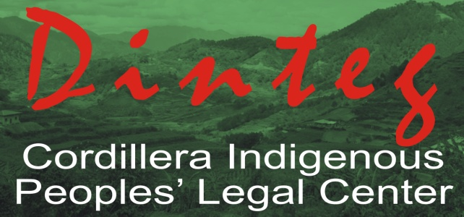
Baguio City, Philippines, 6-15 April 2011
Applications close 15th January 2011
Application Form
Candidates should email a completed application form to dtp@unsw.edu.au
Please include 2 letters of recommendation from referees. Letters should be a maximum of one page in length.
APPLICATIONS CLOSE SATURDAY 15TH JANUARY 2011
Applications will be acknowledged on receipt. Applicants will be notified of the outcome of selection soon after the closing date.
Please do not include any information that you think might affect your security
First Name (s): | Family Name:
Preferred name/known as: | Country:
Male/Female: | Year of Birth:
Do you identify as an Indigenous person/member of an ethnic minority? Y/N
If Yes, please specify:

ORGANISATION DETAILS

Name of organisation/cause you work for:

Position in the organisation:

Email Address 1:

Email Address 2:

Phone Number at work (including country code):

Mobile Number (including country code):

Fax number (including country code):

Postal Address 1:
City: | State:
Country: | Post Code:
Organisation’s website:

YOUR WORK AND EXPERIENCE
- Present Occupation:
(Please provide your title and a brief description of your duties)

- Write a short summary of how your role and other practical experience you have had is relevant to this program:
(PLEASE LIMIT YOUR ANSWER TO 3 PARAGRAPHS. We are specifically interested in the work you do as an individual for your cause or organisation. We would like to know the activities you do on a day-to-day basis. What are your job responsibilities (programs, sectors/issues, approaches, level – eg: national, community)?)
- Have you had experience in working on Human Rights Issues/ Concerns of Indigenous Peoples?

- Please tell us how this training program will assist your advocacy work in the future? How will you apply what you hope to learn in this program to your advocacy work?

- Outline the reasons why you would like to participate in a DTP course on Human Rights and Indigenous Peoples.

- Please provide a brief outline of your expectations of this training program.
- On a scale of 1 to 5, (1 = Not confident, 5 = Very Confident), how confident do you feel about your skills related to:

- Lobbying: 1 2 3 4 5

- Media: 1 2 3 4 5

- Reading and understanding 1 2 3 4 5
human rights documents:

- Building alliances: 1 2 3 4 5

- Where do you see the biggest challenges in promoting human rights in relation to indigenous peoples?

- Where do you see the greatest opportunities for promoting human rights in relation to indigenous peoples?
- Please briefly tell us about a project, campaign or issue on which you are working/have worked on that you think is relevant to this program and that you will be willing to share information about with other participants during the program.

EDUCATION
What level of education have you completed? Please mark ‘X’ in the appropriate square:
Primary | Secondary | Tertiary
Degrees / courses successfully completed, the year obtained, and name of institution: (Please list)

Other training, including previous human rights training: (Please give details)

REFEREES
Please include 2 letters of recommendation with your application. Letters should be a maximum of one page in length.

Name 2 referees with email, telephone and fax.

(Please nominate 2 people who know your NGO and/or your human rights work. It is preferred if at least one referee occupies a senior/supervisory position in your organisation.)
Referee 1
Name of Referee
Title of Referee
Phone Number
Email Address
Referee 2
Name of Referee
Title of Referee
Phone Number
Email Address
LANGUAGE
If you are accepted you will be required to participate in discussions and role plays in English.
Is English your first language?

YES ( ) or NO ( )

If English is not your first language, please mark with an ’X’ how comfortable you are with English:
 | Fluent | Good | Intermediate | Basic
Speaking
Writing
Understanding
SPONSORSHIP
How will you fund your travel expenses and the course fee of US $2500 (which covers food, accommodation, materials and training fee)?
- I / my organisation will be able to pay a course fee of US $2500 as well as travel expenses.
- I request a financial subsidy for a course fee of US $2500 only and I / my organisation will cover my travel costs.
- I request a full financial subsidy including a course fee of US $2500 as well as my travel costs.

Have you had any experience with fundraising or writing funding proposals?

Do you or your organisation work in partnership with other NGOs or government organisations?

CONSENT
Do you give us consent to use the information provided in this form to write a short biographical paragraph about you that will be given to trainers, participants and others for the purposes of informing them, seeking funding on your behalf, advertising this training and in future DTP publicity material?
YES NO

Do you have concerns about your personal security that we should consider before using the information you have provided here?

YES NO
OTHER
42. How did you hear about this training?

Date completed: ___________________

